Assignment No 1

Submitted by : Muhammad Hammad Ayoub
Submitted to : Ms. Rashda Nazeer
Department : BS Artificial Intelligence
Section: A
Submission Date: 23 October 2026
Programming Fundamentals

Lab 1
Task 1
Write a Task that prints your name, roll number and Program on separate lines.

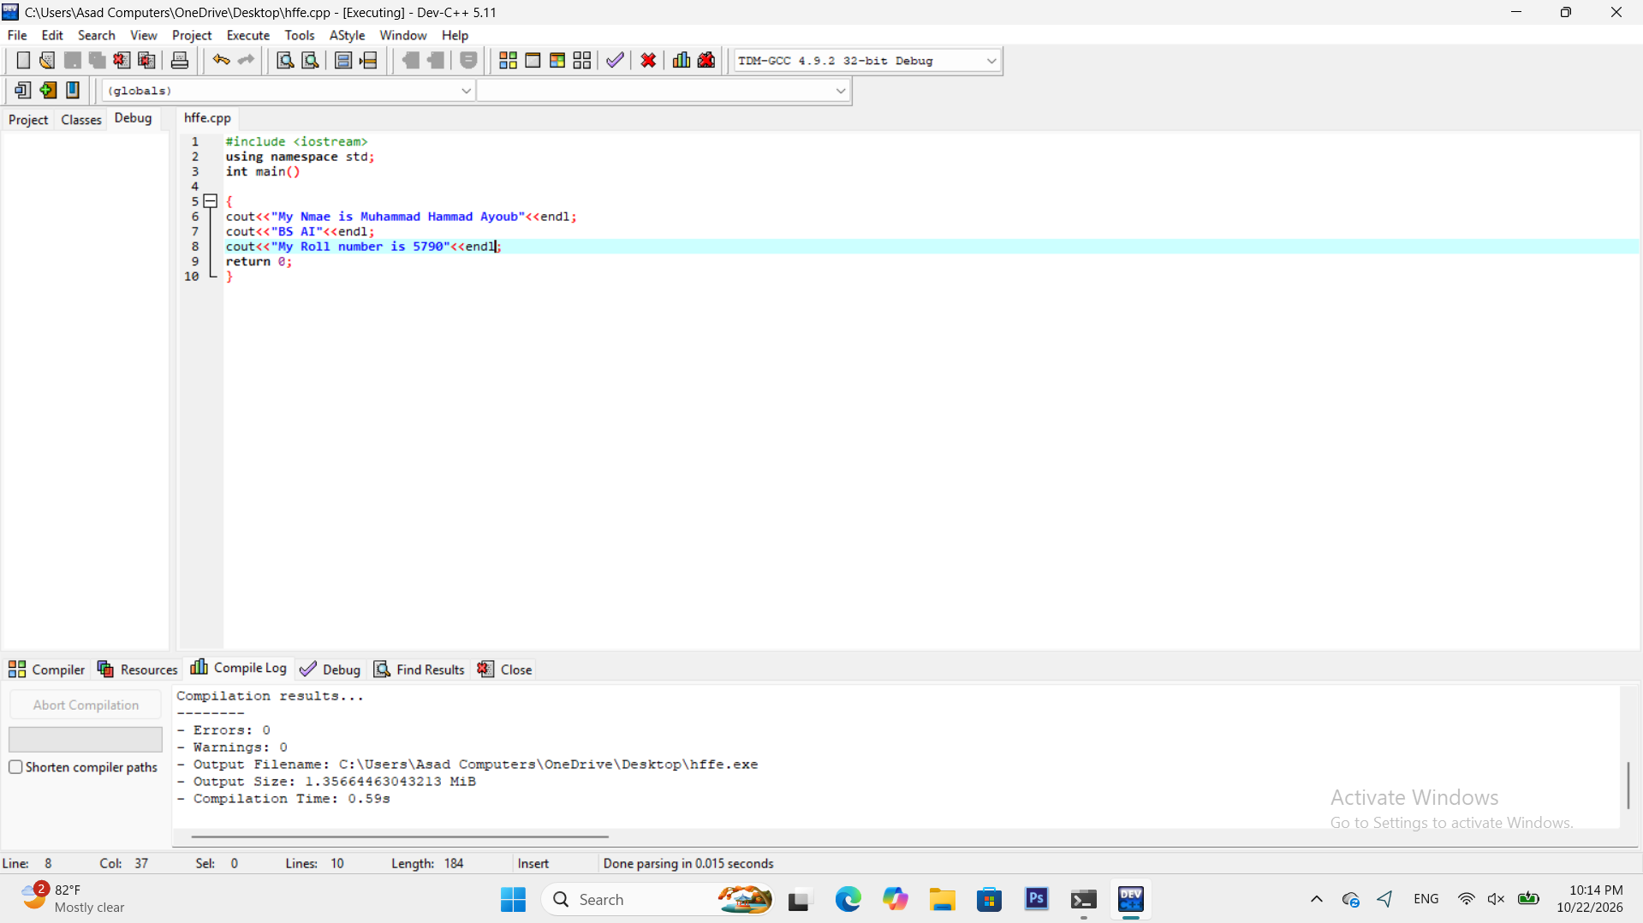

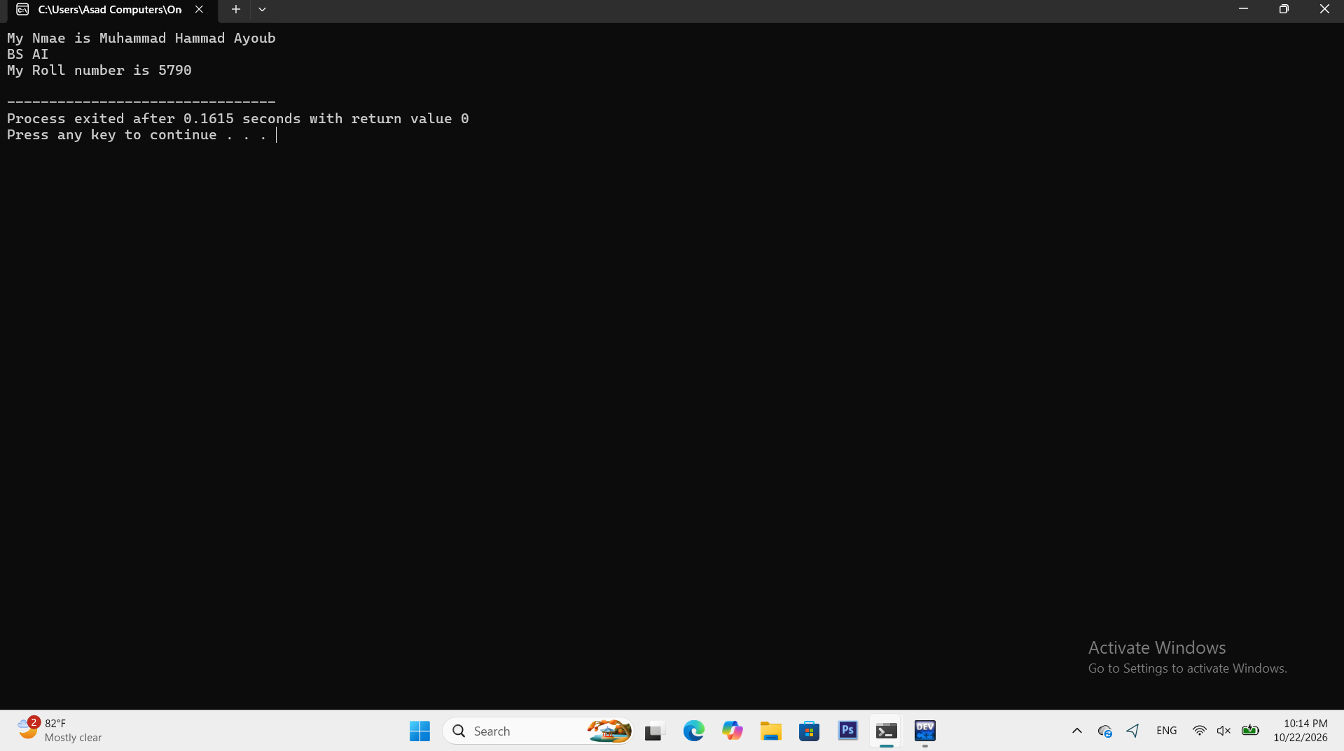
Task 2
Print a box of asterisks 5 rows high and 10 columns wide using cout statements.
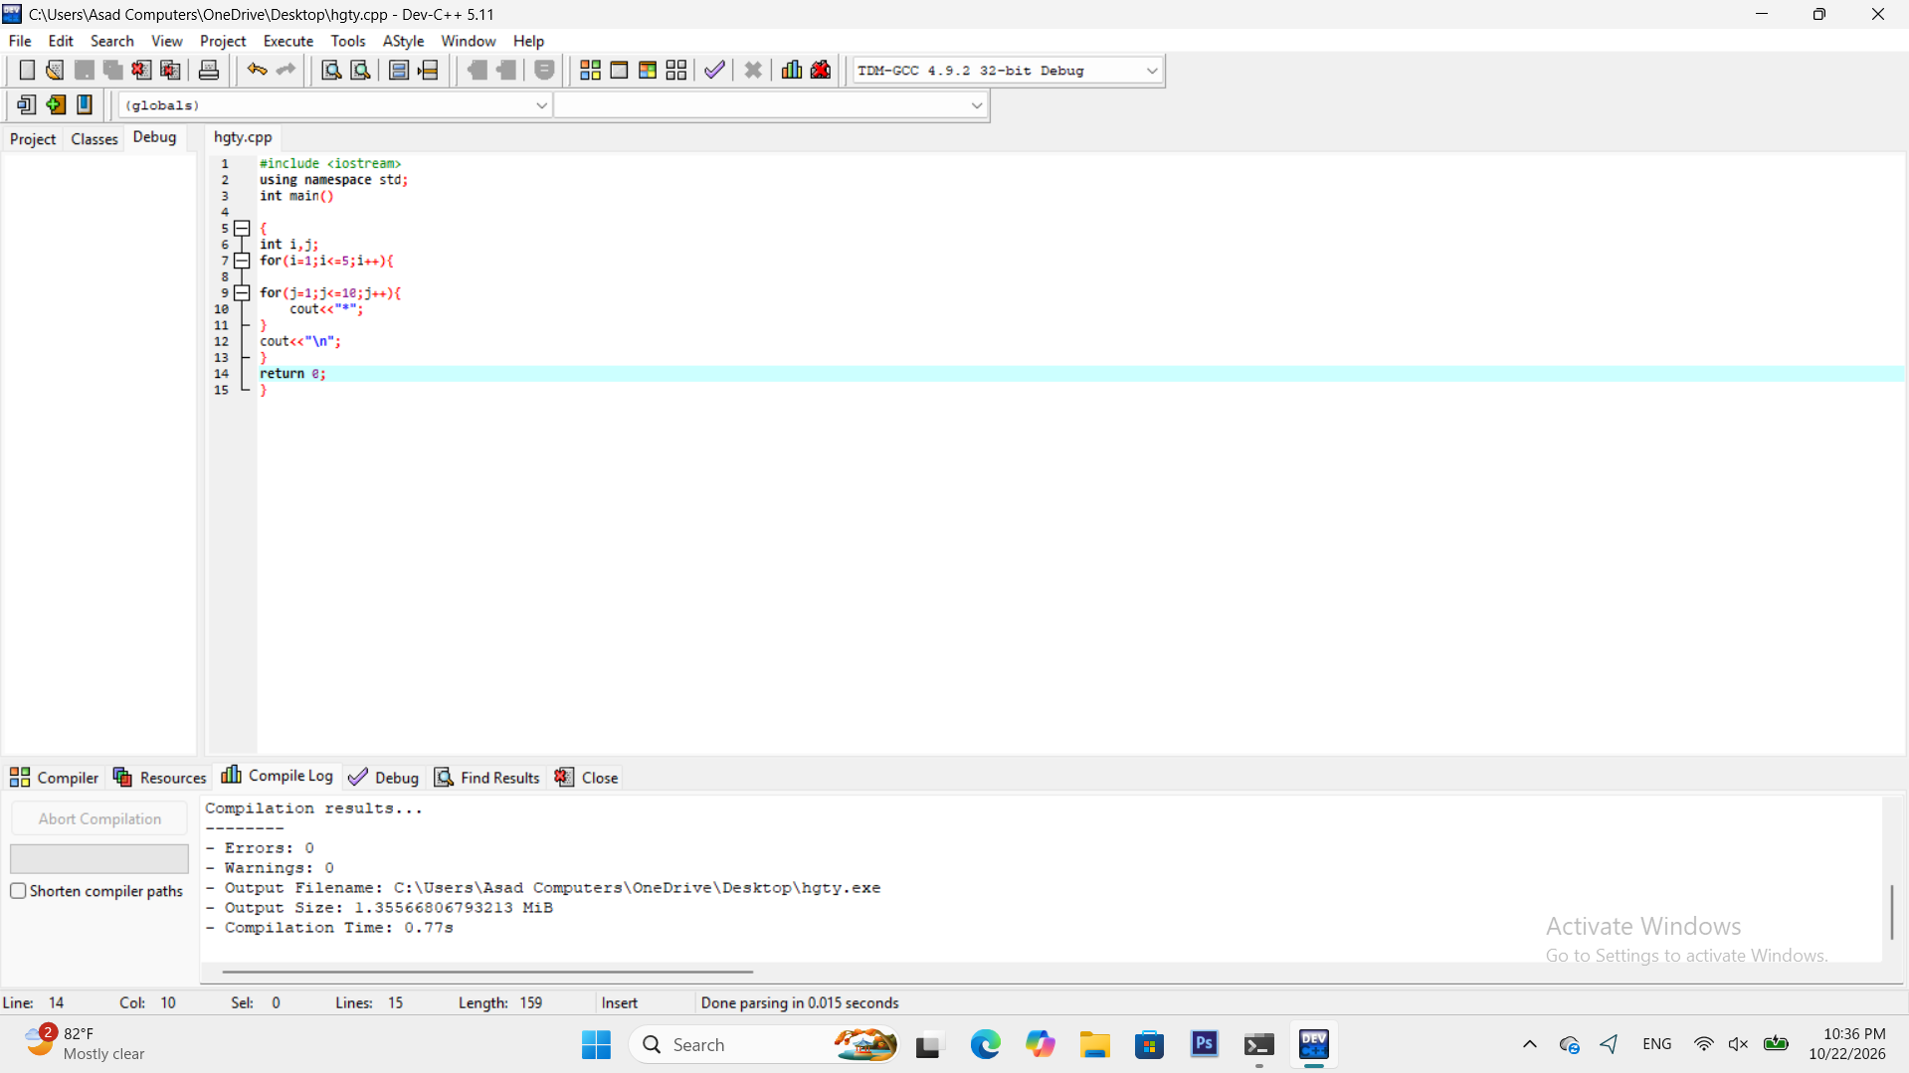
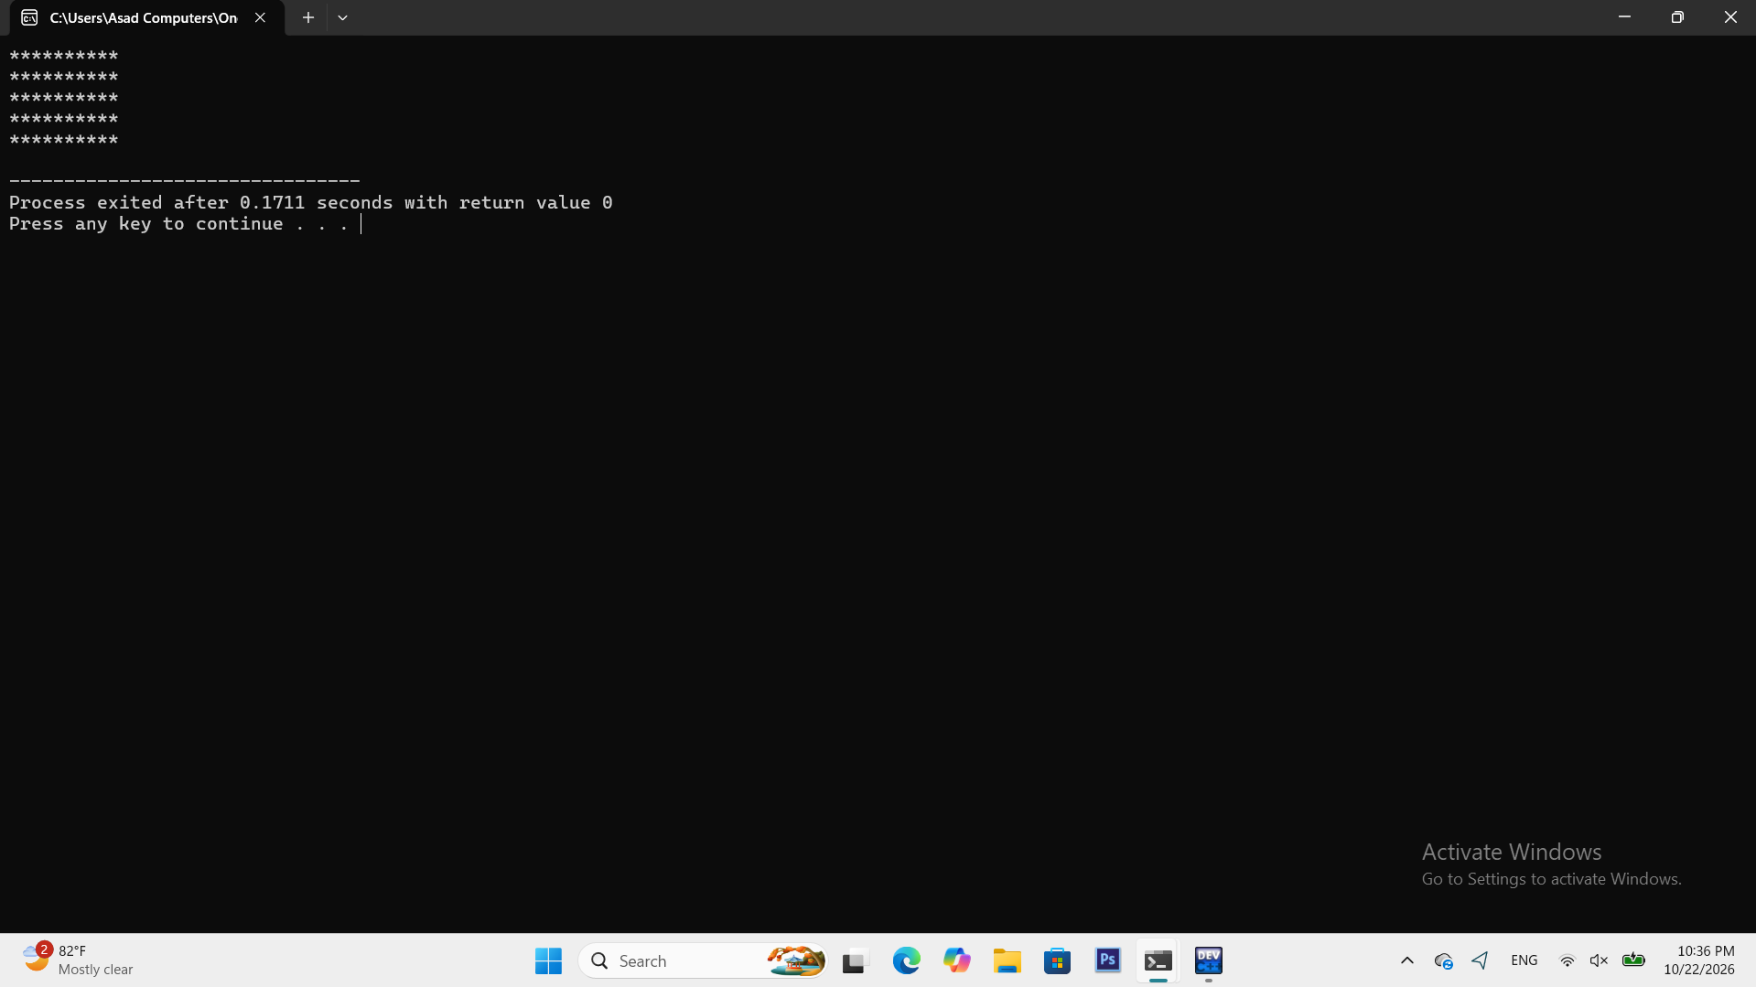
Task 3
Record three different compiler errors and explain what caused each.
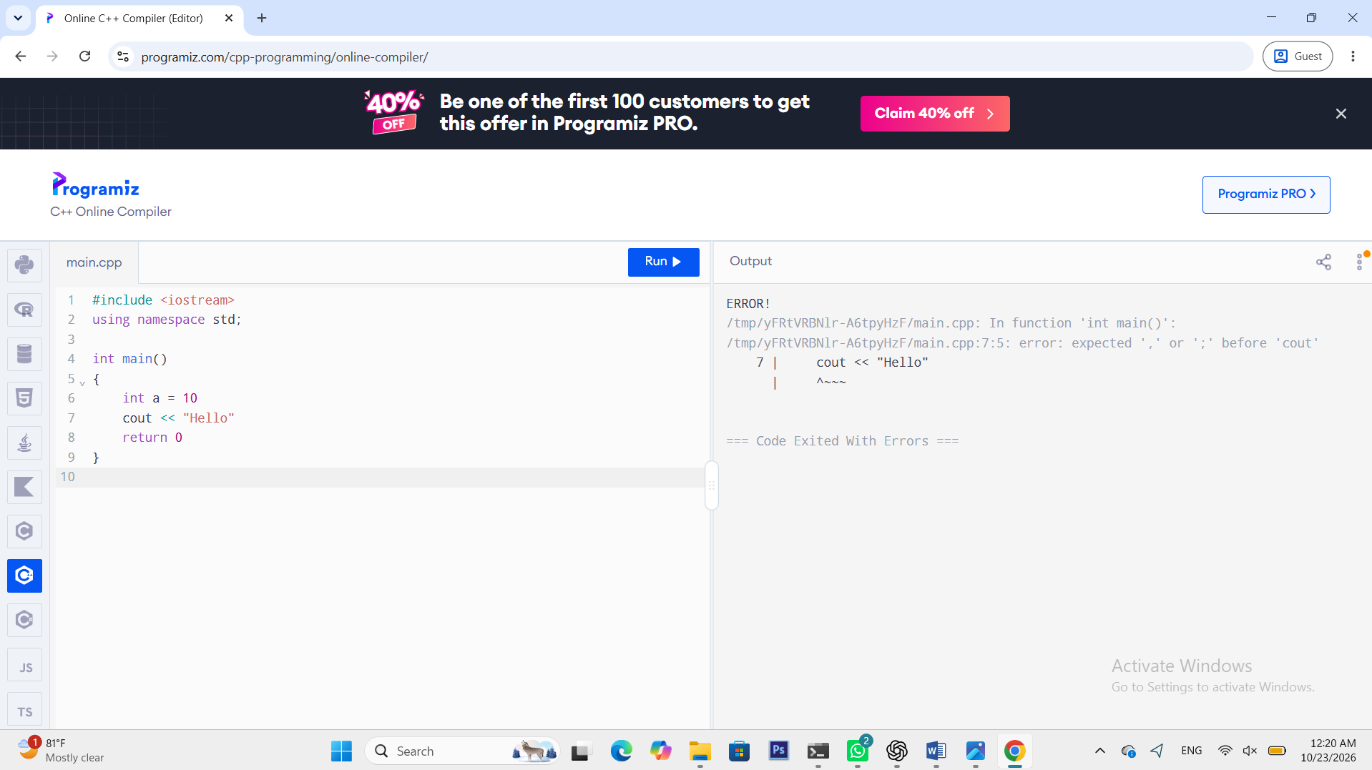

Three errors and their causes:
- Missing ; after int a = 10.
- Missing ; after cout << "Hello".
- Missing ; after return 0.

Lab 2
Task 1
Read the length and width of a field in metres and print its area in square metres andin kanals (1 kanal = 505.857 m2)
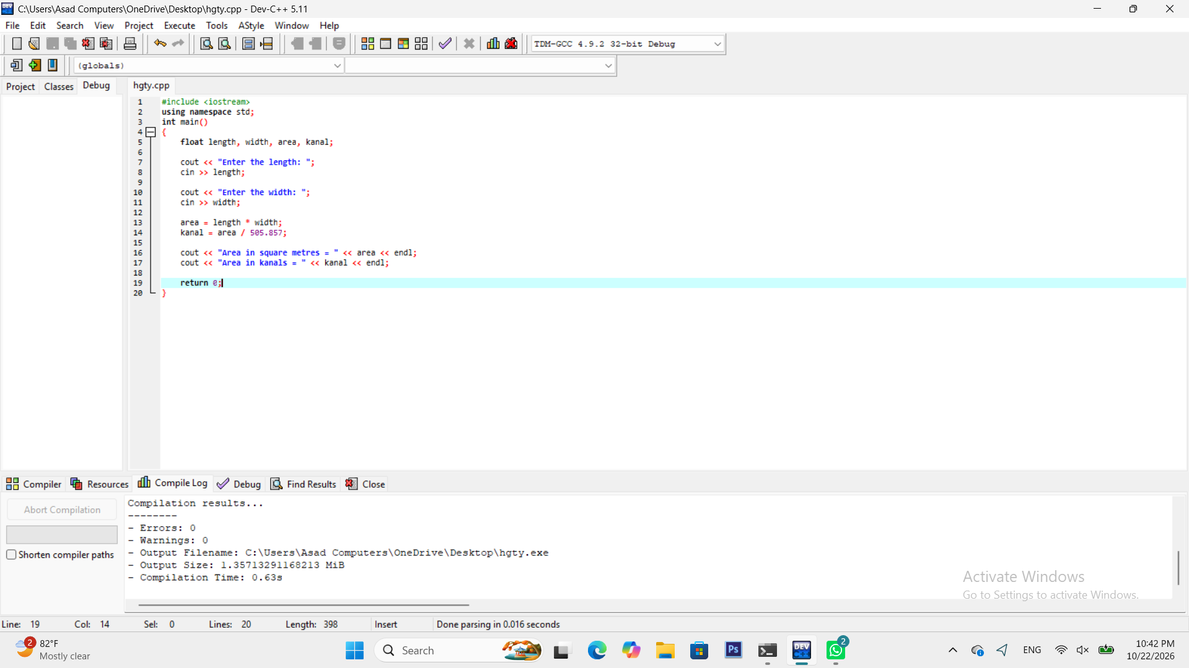
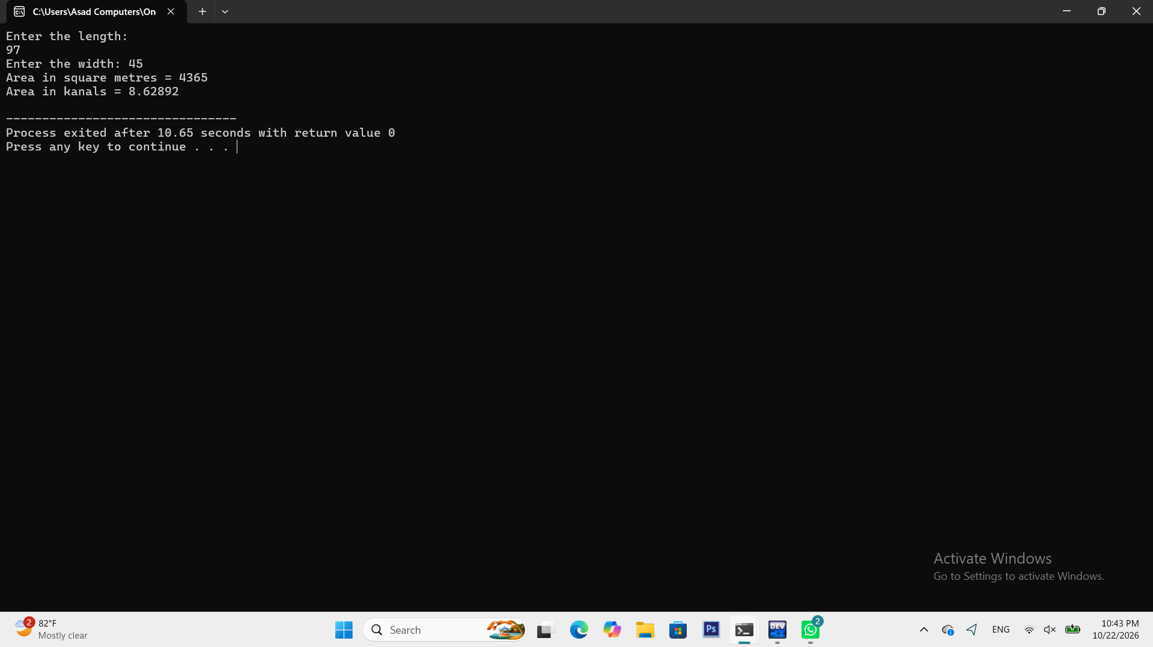
Task 2
Read the Temperature in Celsius and print it in Fahrenheit and Kelvin with two decimal places.
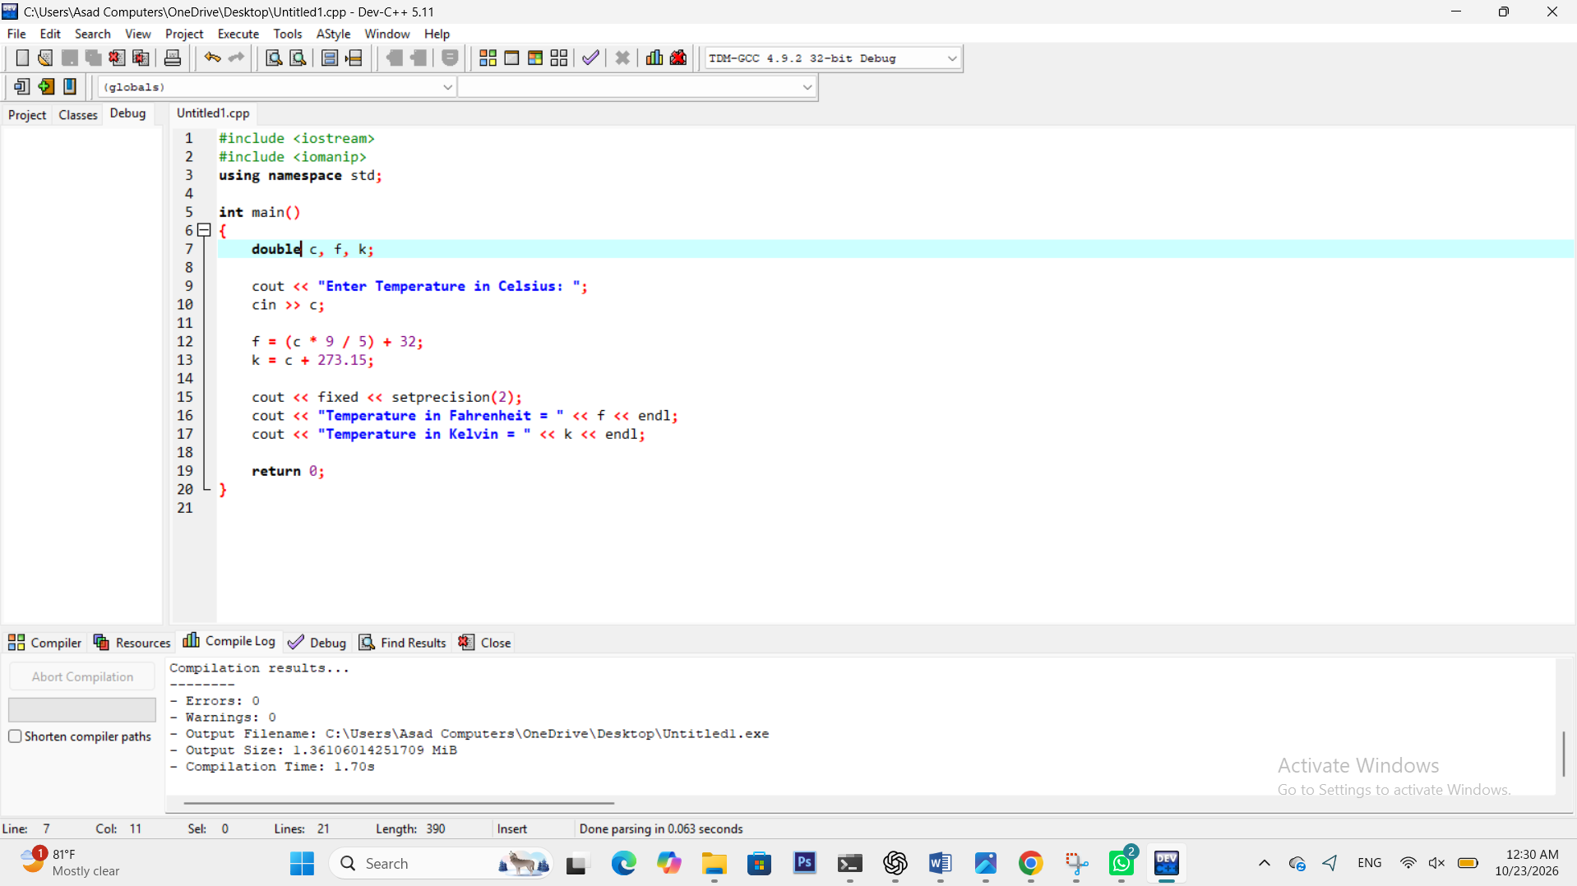
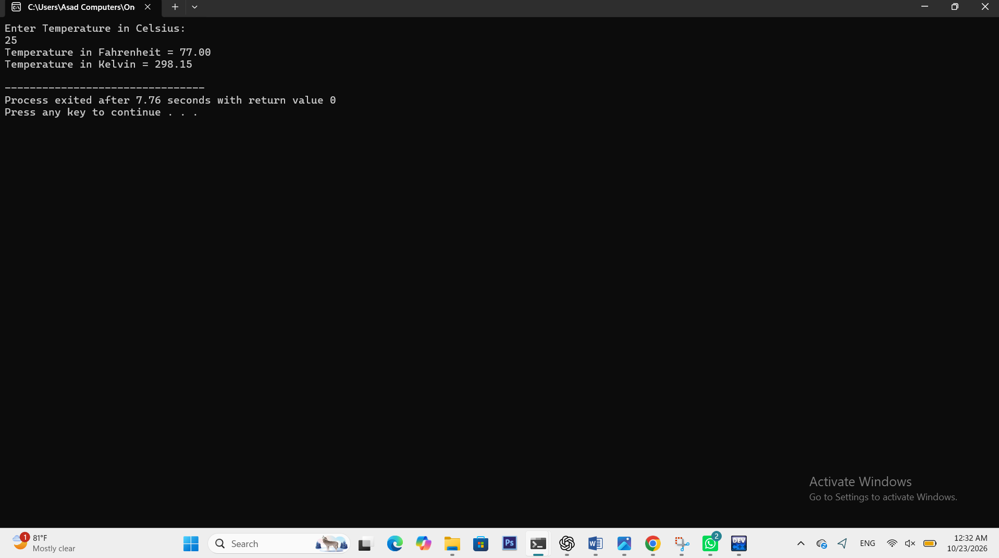
Task 3
Read a number of seconds and print it as hours , minutes and seconds using / and %.
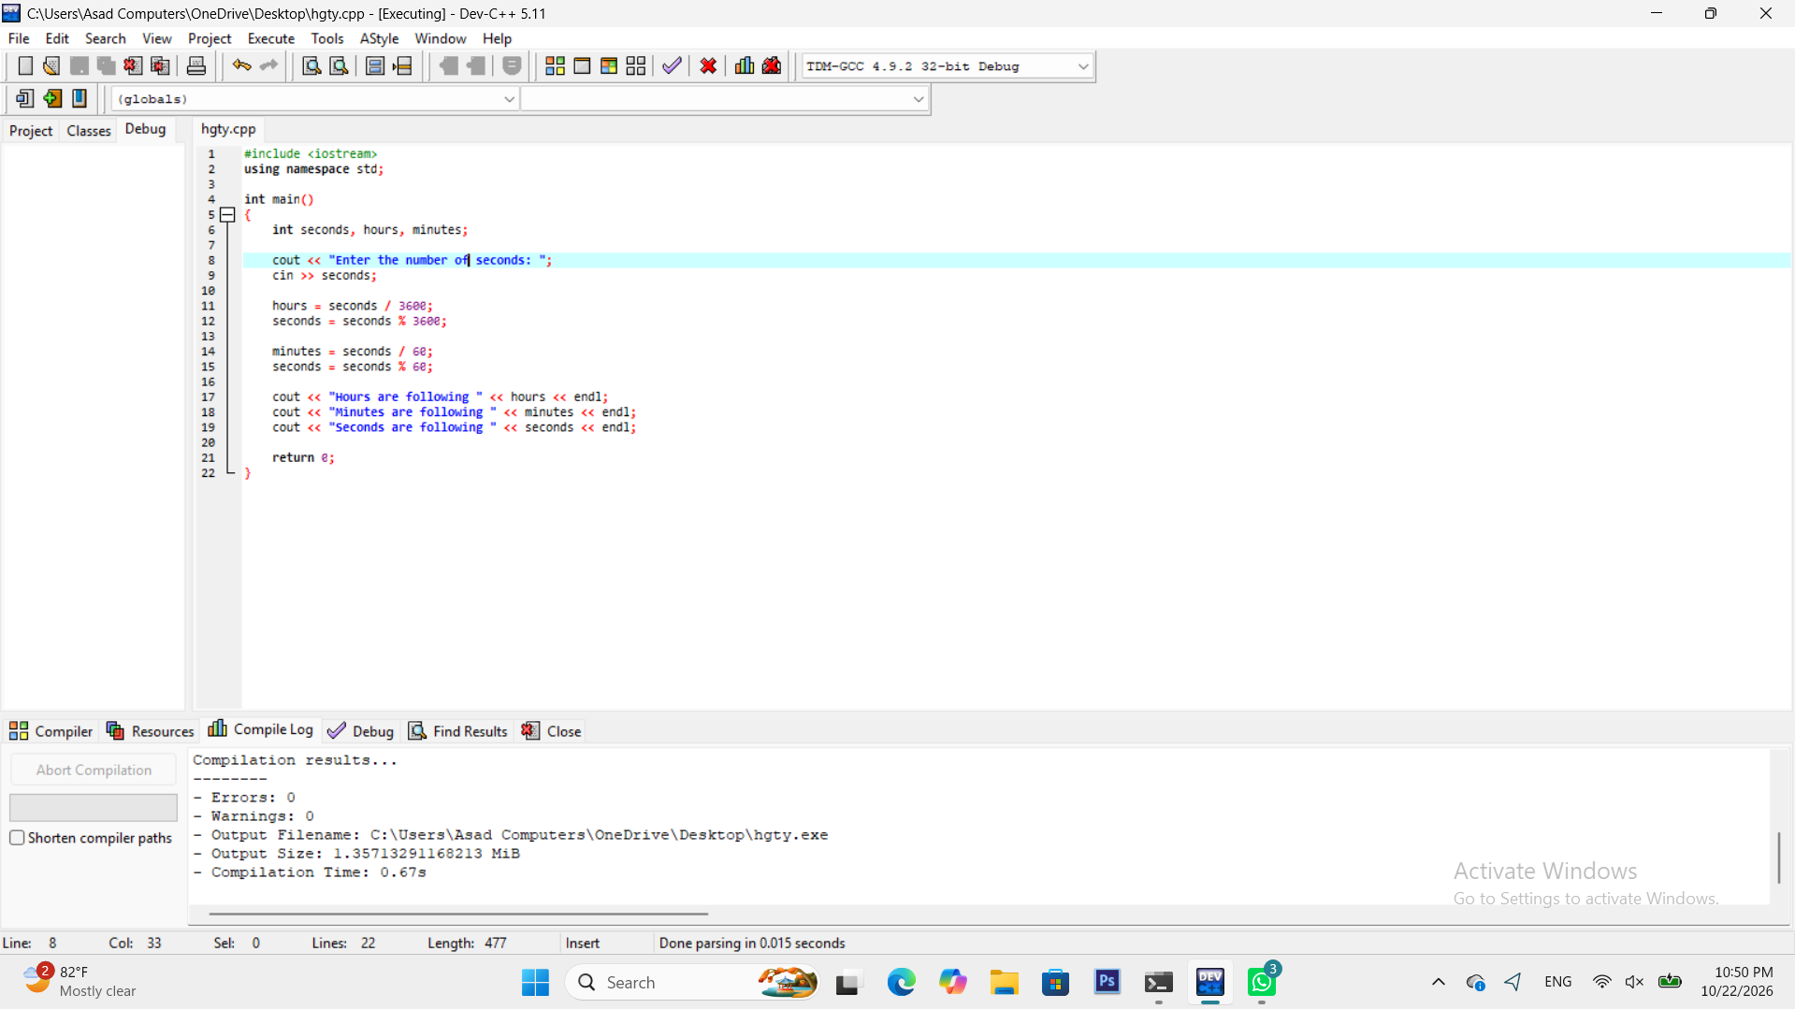
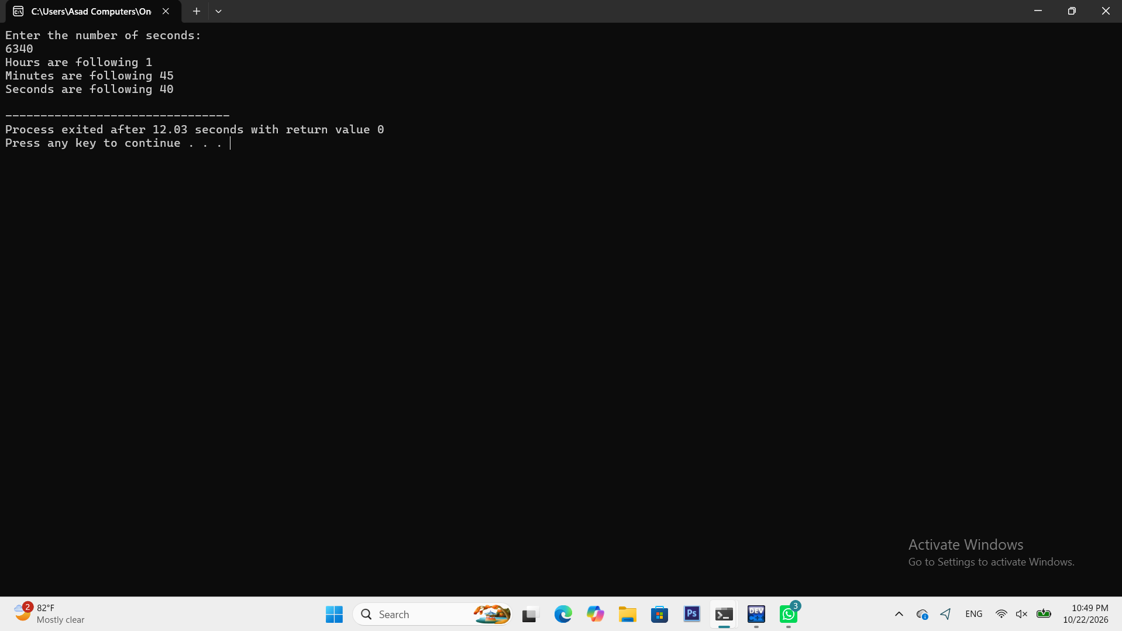
Task 4
Demonstrate overflow by adding 1 to INT_MAX and explain the result.
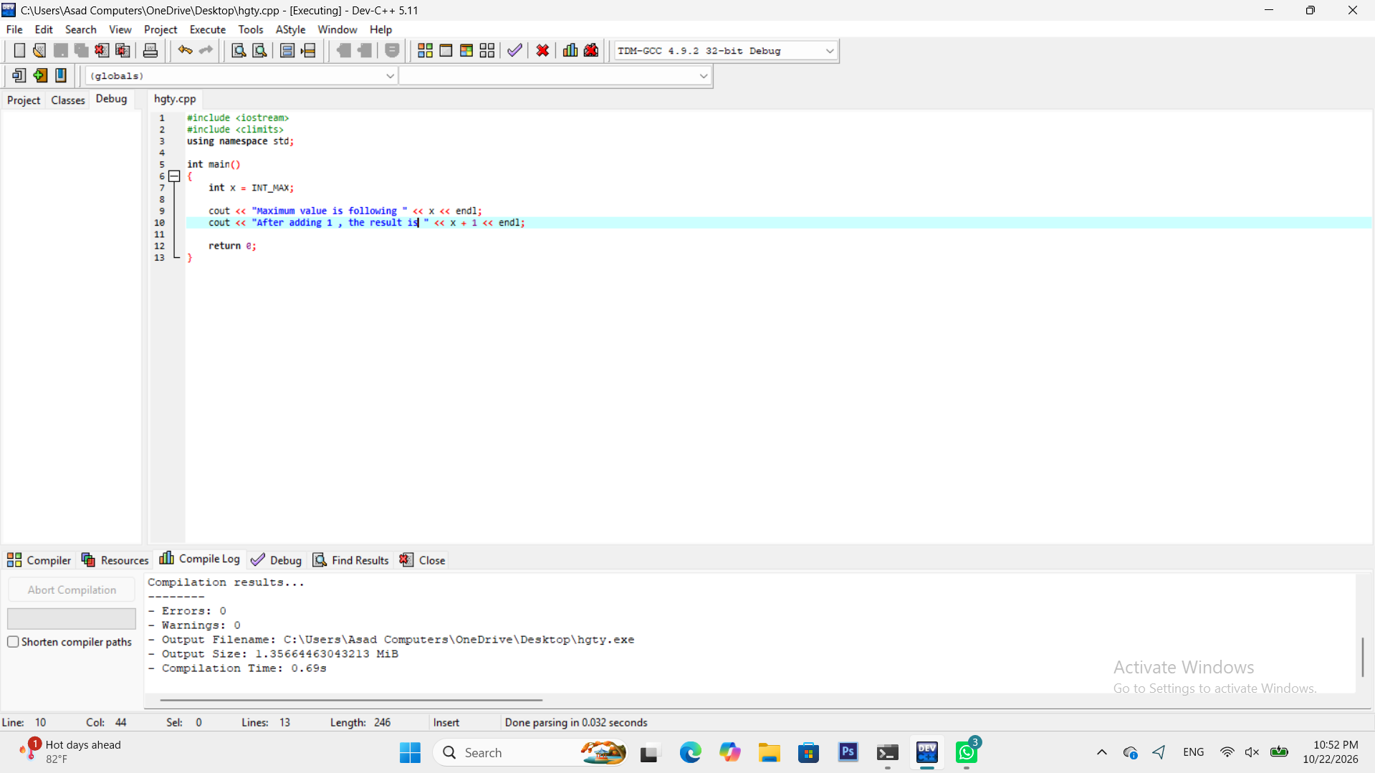
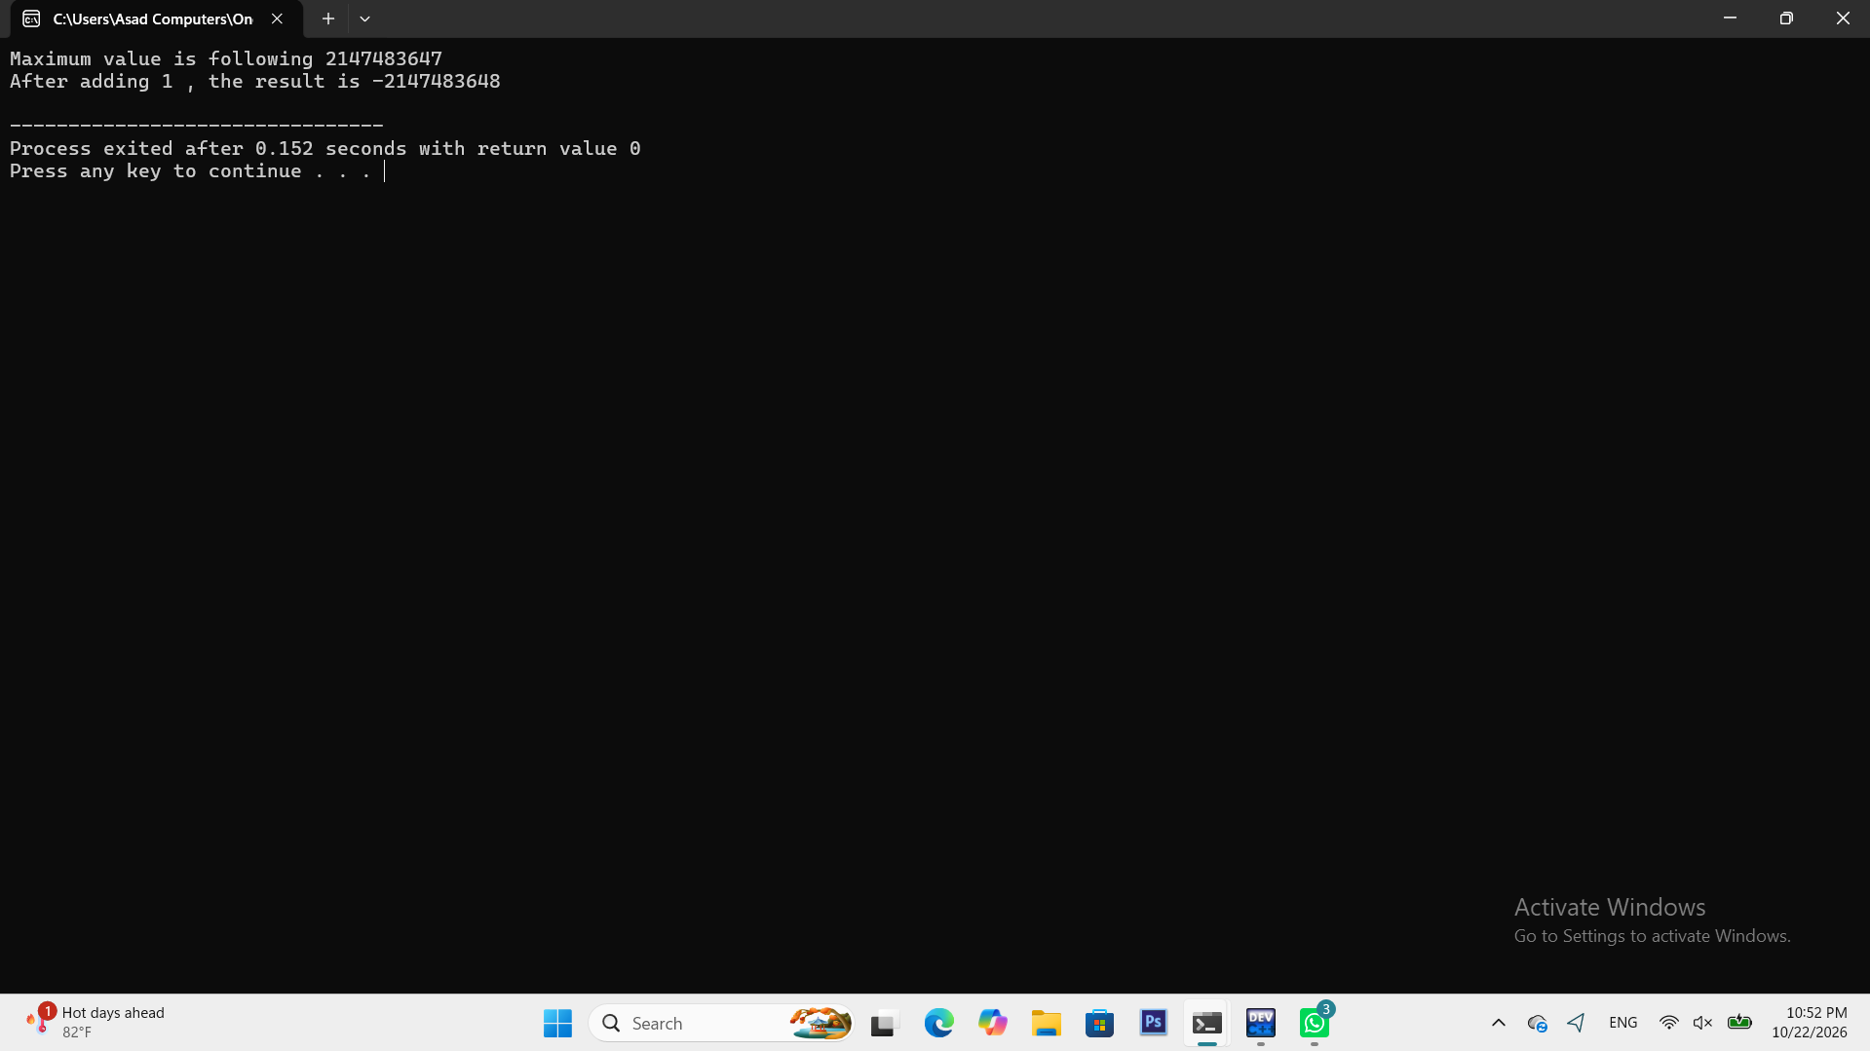
Explanation:
Adding 1 to INT_MAX (2,147,483,647) causes integer overflow because a 32-bit signed int can only hold values up to 2³¹−1. In binary, INT_MAX is 0111...1111; adding 1 carries through all bits and flips the sign bit, giving 1000...0000, which in two's complement equals INT_MIN (−2,147,483,648). So the value wraps around from largest positive to smallest negative, like an odometer rolling from 9999 to 0000. (Note: in standard C++, signed overflow is technically undefined behavior — the wraparound is just what most compilers do.)
Lab 3
Task 1
Read three numbers and print the largest using nested if.
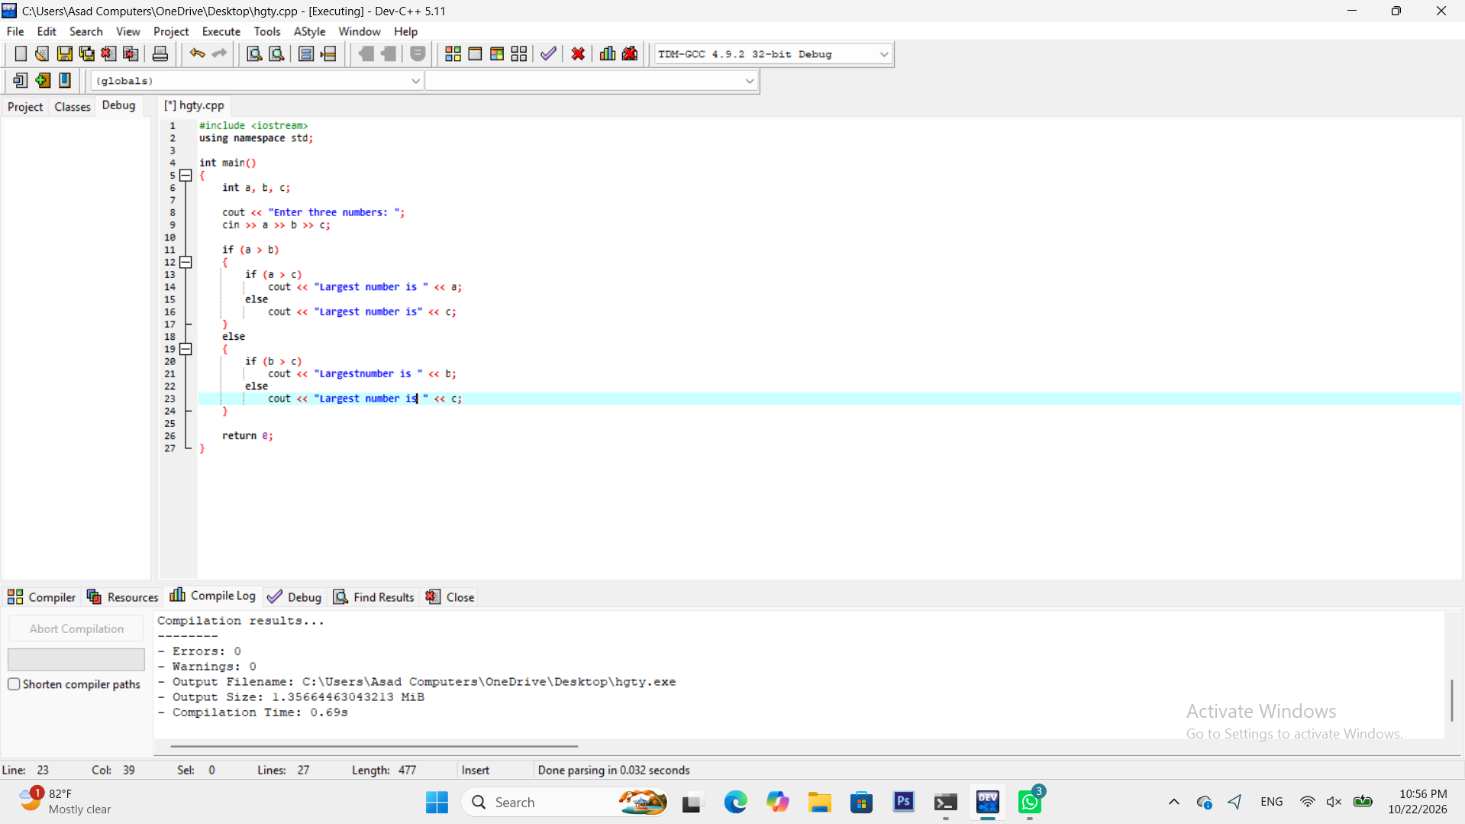
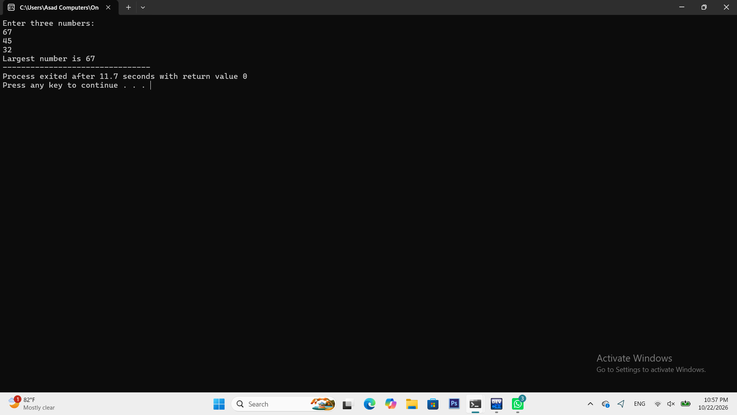
Task 2
Write a grade calculator for marks 0 to 100 using the grading scheme of the University semester rules.
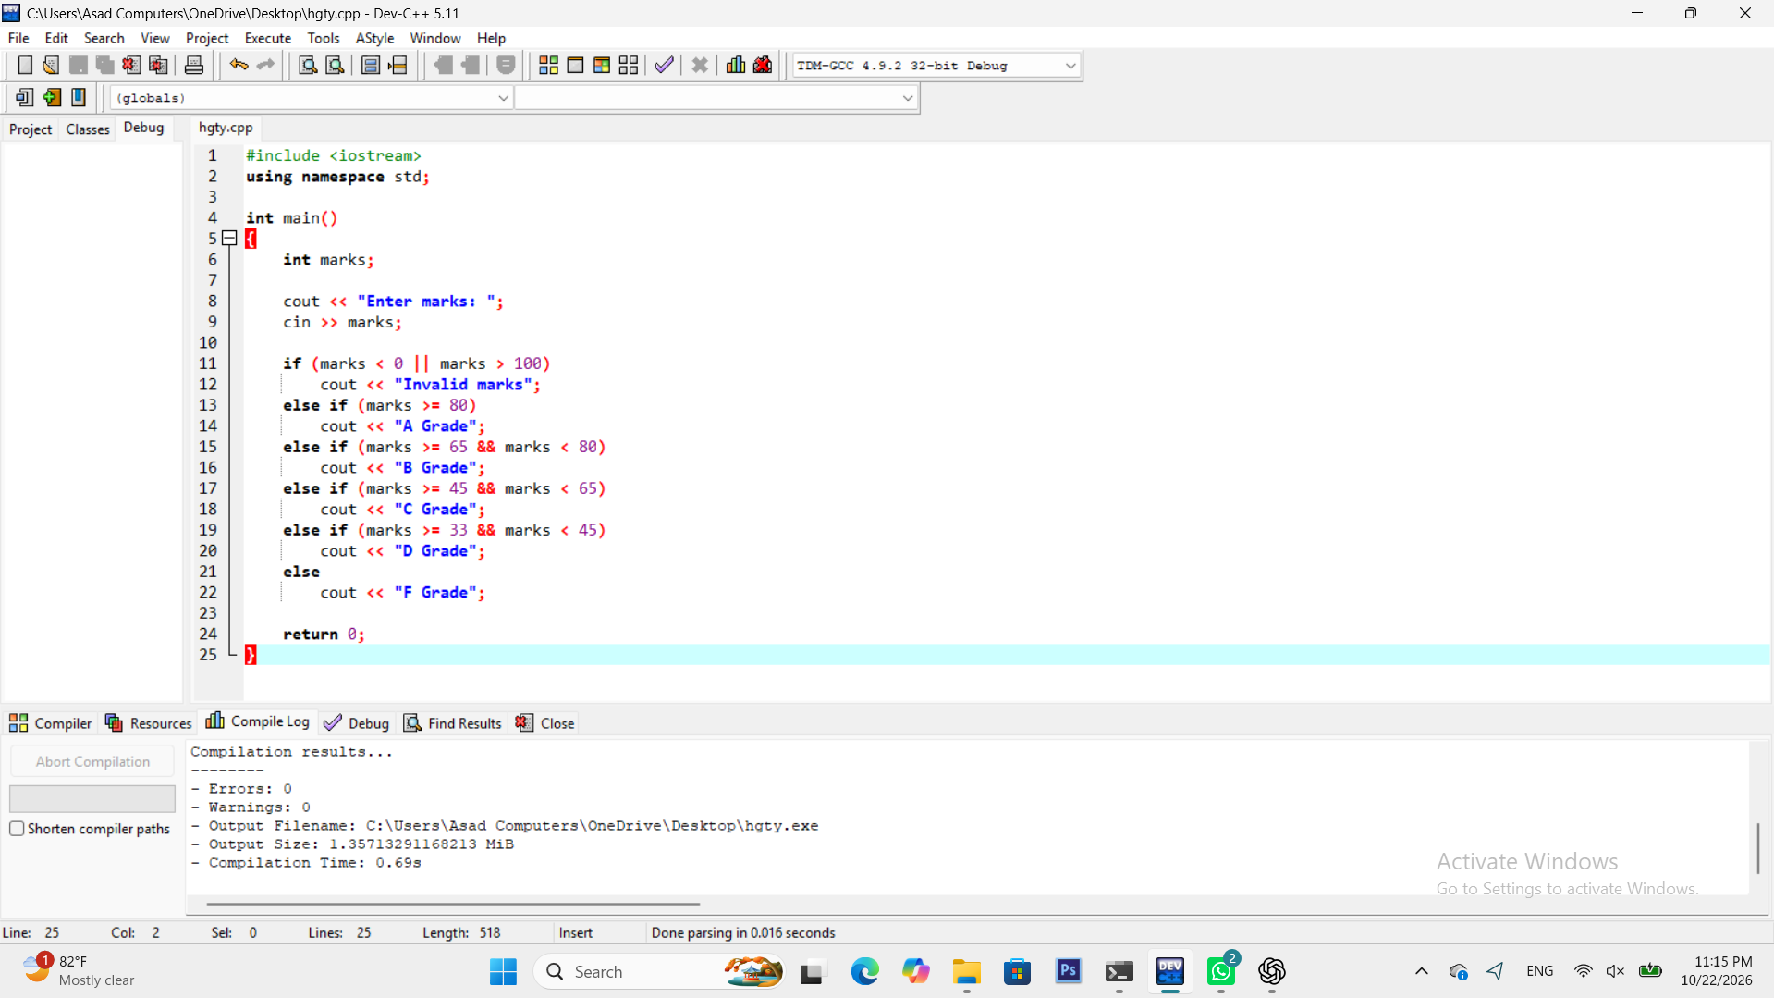
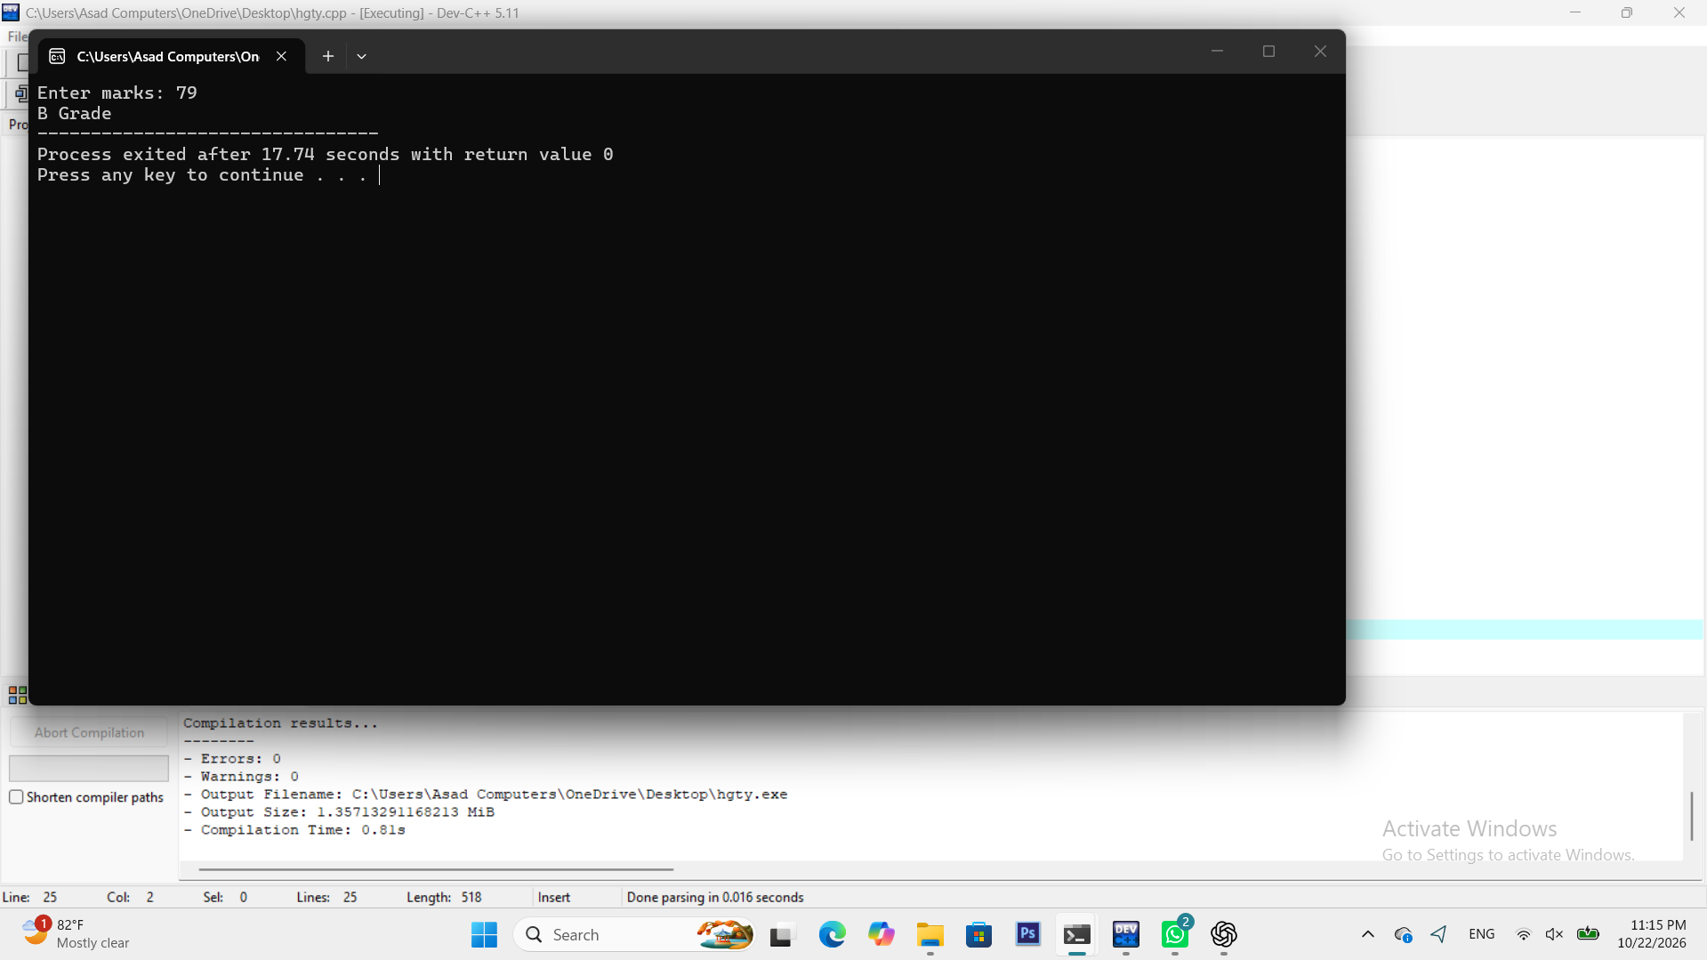
Task 3
Write a menu driven calculator (+,-,*,/)using switch, handling division by zero.
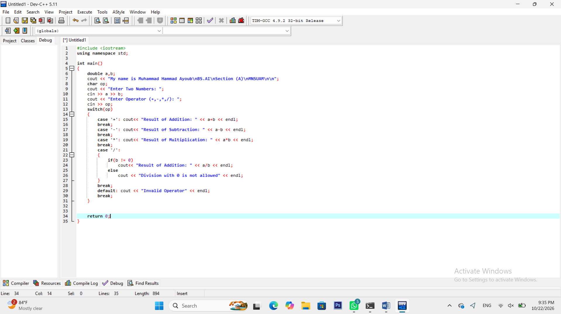
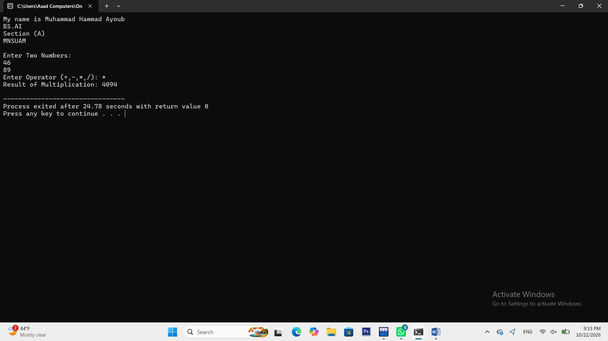
Task 4
Determine whether a year is a Leap year.
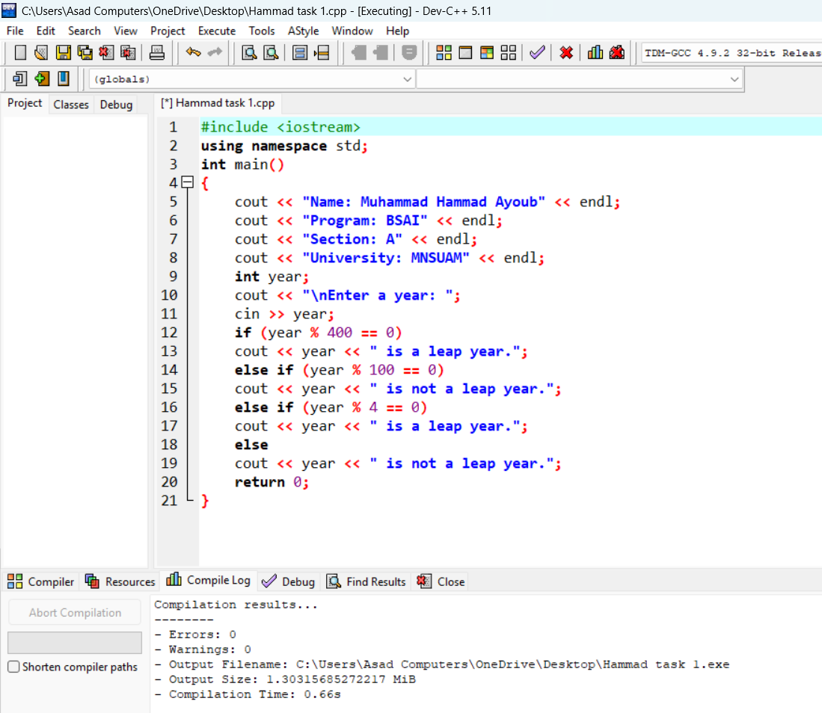
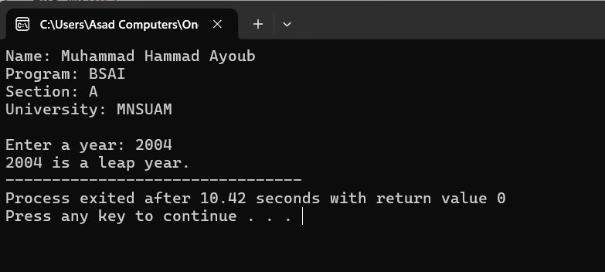
Lab 4
Task 1
Print all Prime numbers between 1 and 200.
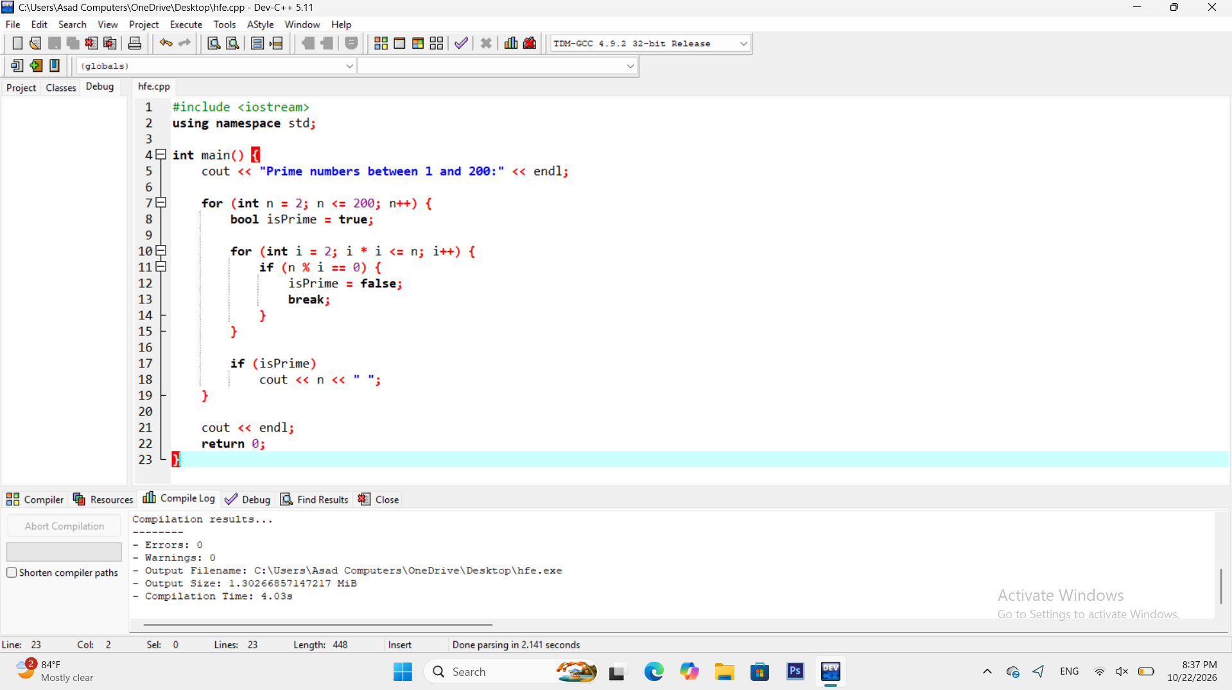
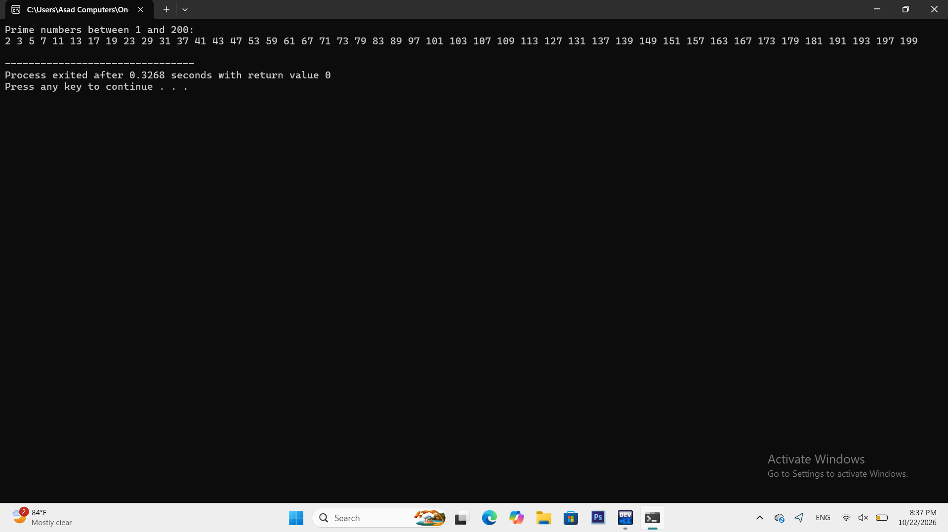
Task 2
Print a right angled triangle and a pyramid of stars with n rows.
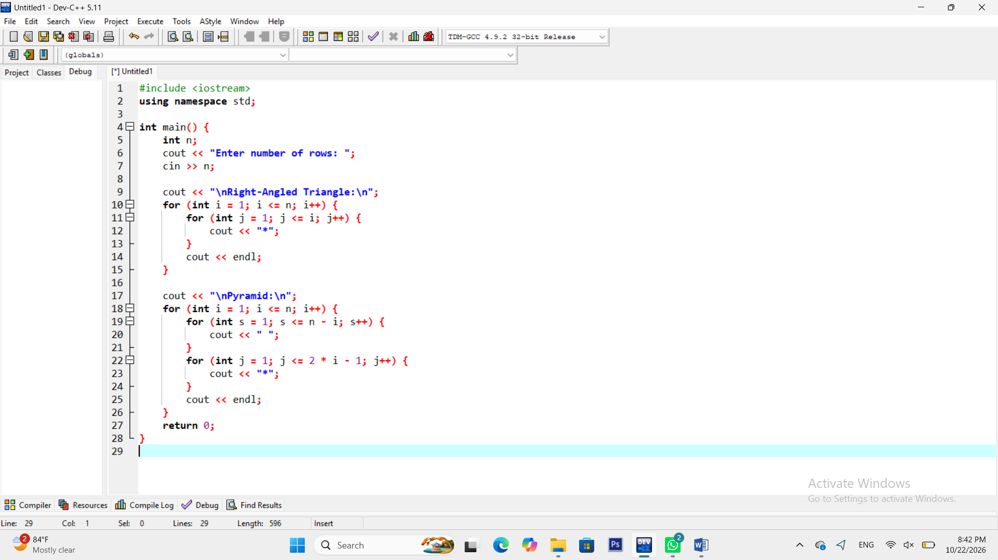
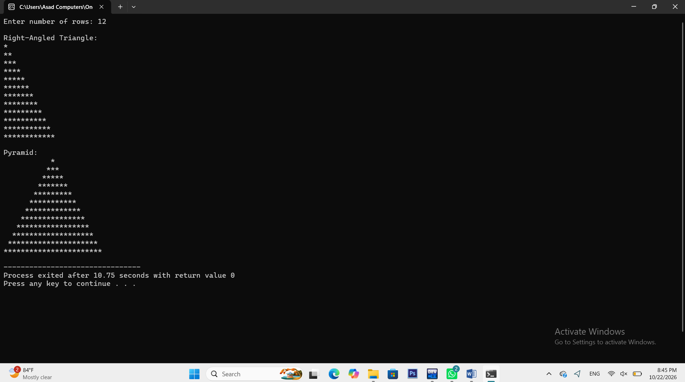
Task 3
Compute the factorial and the sum of digits of a number.
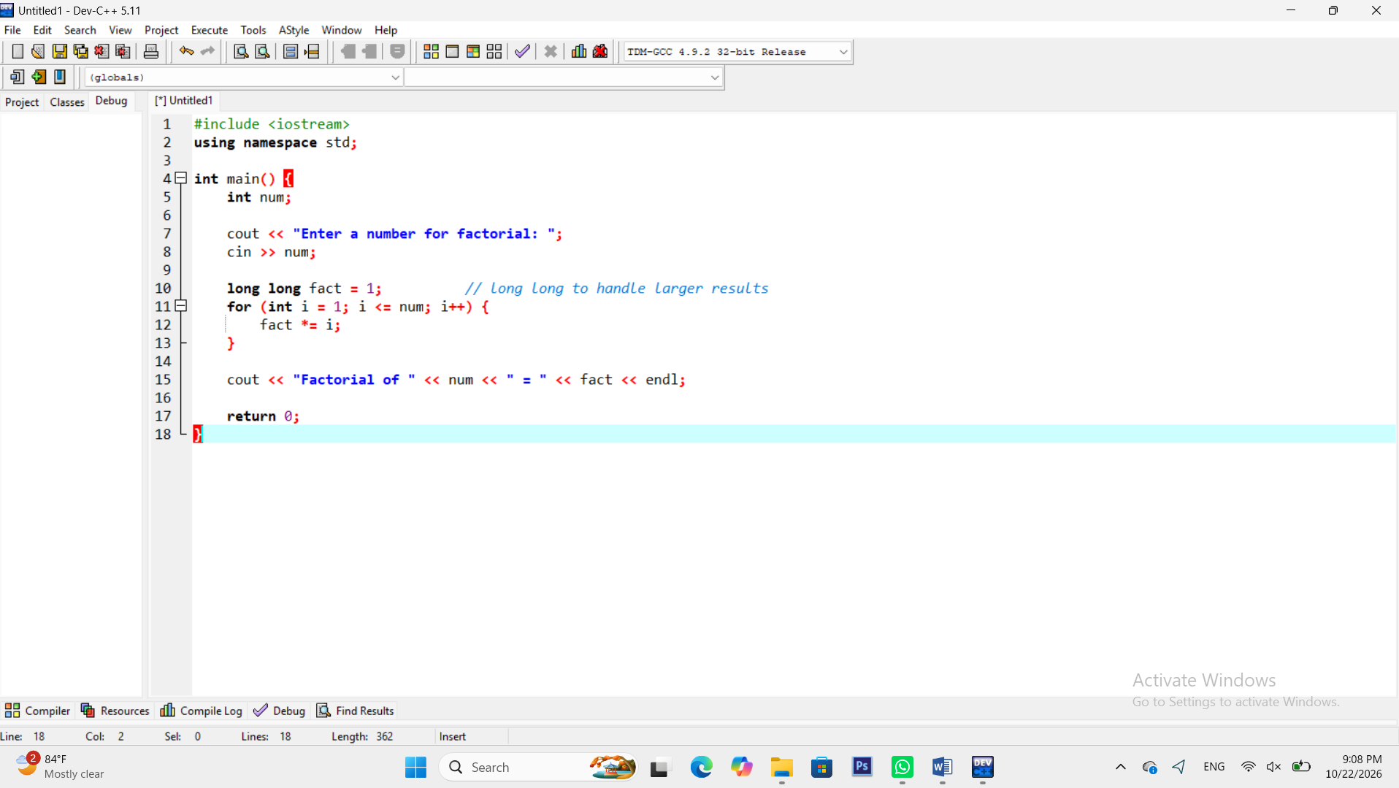
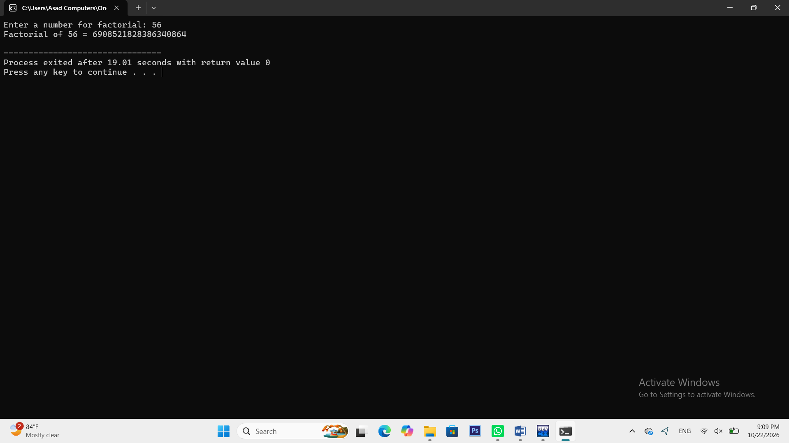
Task 4
Implement a number-guessing game with at most seven attempts .
